Dave Maino | . | name
Lighting/Electrical | . | option
Dr. Mistrick | . | advisor
TCES | . | building
Incline Village, NV | . | location
12/8/05 | . | date
Proposal | . | title
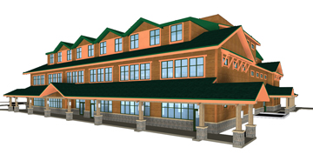

This report, along with supplemental information, can be found at “P:\ae 481\proposal”
Full report available for download from the web at “http://www.arche.psu.edu/thesis/eportfolio/current/portfolios/jdm341/”
Executive Summary - Depth:

The depth and breadth proposals explain what I will redesign and how it will be redesigned during the spring semester in 2006. The four spaces chosen shall involve a redesign of the lighting and electrical systems. The lighting design will focus on task-oriented lighting design, with strong emphasis on controls. At the same time, every effort will be made to reduce power densities so as to promote a “green” building design. The electrical redesign will encompass the lighting redesign, but will also involve switching the main building service from 208Y/120 to 480Y/277V. In addition, the existing cogen unit will be investigated to see if replacing the stand-by generator is a possibility. Also, the photovoltaics will be investigated to see if it makes sense from a monetary versus LEED credit standpoint to add more cells.
Executive Summary - Breadth:

My breadth work, in order to further my knowledge of the various aspects of Architectural Engineering, will consist of a mechanical study as well as an in-depth study of LEED standards. The mechanical breadth work will involve an analysis of the cogen unit and solar hot water heating system. Since the building is going for LEED platinum rating, the LEED points analysis will consist of examining the points earned to verify that there are no other places where possible points may be earned.
Background:

Problem:
The population in the lake Tahoe region has been steadily increasing, and with such an increase comes a strain on the local environment. The Tahoe Regional Planing Association (TRPA) has attempted to regulate things such that the impact is minimized, but the impact is still there, nonetheless. For this reason, Sierra Nevada College, U.C. Davis and the Desert Research Institute have teamed up to provide a research facility capable of studying the effects of the local population on Lake Tahoe and the Lake Tahoe Basin. They wished to develop a “green,” eco-friendly, LEED platinum building in which to conduct their business. The facility in question is the Tahoe Center for Environmental Sciences (TCES).

TCES is both a research facility and an educational facility. Lab, office, classroom, and lecture spaces are combined to provide professionals as well as students a place where research and learning can be accomplished side by side. Four spaces have been selected to be the focal point for my analysis of TCES. The exterior facade will be examined mainly with regard to lighting design and power consumption, with an emphasis on retaining LEED standards and minimizing light trespass. From here I will move to the entry lobby, which is the main circulation space for the building. Daylight integration with electrical lighting will be a major focus of this space's redesign. The case study classroom, which is adjacent to the lobby, will serve as an exercise in controls systems for electric lighting systems as the control scene in that space will need to be very flexible. Finally, the chemistry lab space will allow me to show how much I am able to decrease a space's power requirements since it does not currently meet ASHRAE 90.1.

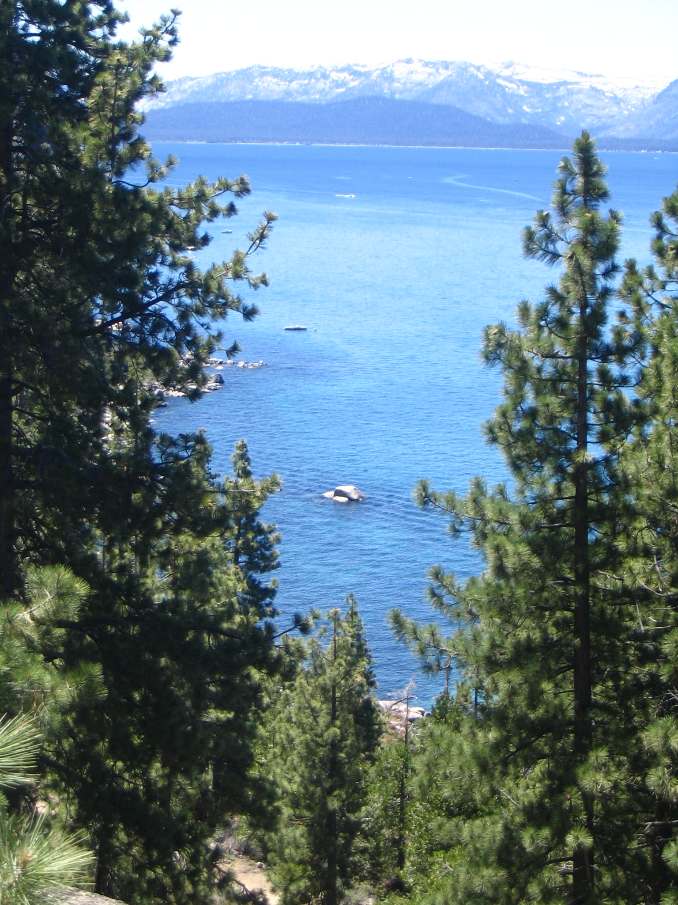
Depth Work:

Lighting – Problem:
A large portion of the design problem will stem from the owner's desire to create a LEED platinum building. To do this, power densities significantly below ASHRAE 90.1 will need to be present in each space. Also, daylight will need to be integrated in as many spaces as possible (although preliminary design investigations show that this may only be possible in the lobby). This integration of daylight will require special controls systems to vary the level of electric light depending on the daylight levels present. Another issue of concern is glare, especially for safety reasons on the stairs in the lobby and in the chemistry lab where potentially hazardous chemicals are present. Also of importance are controllability of the lighting systems, light distribution in the spaces, and the appearance of the luminaires to fit with the industrial look of the interior of the building. For more detailed information about lighting concerns for each space, please consult the reports entitled “Tech 1” and “Tech 3” which can be found on my website. All of these issues must be addressed while at the same time providing appropriate illuminance levels for the tasks required in each space.

Lighting – Solution:
The spaces selected for redesign are the lobby, exterior facade, case study classroom and chemistry lab. The lighting design will focus on the natural aspect of the materials and character of the building, and will help to reinforce the idea that this is a “green” building. See the report entitled “Tech 3” posted on my website for more details.

Lighting – Solution Method:
The lighting design that will be proposed shall contain all the elements which have been mentioned so far. IES design criteria shall be followed, and strict adherence to ASHRAE 90.1 will be observed. Avery attempt will be made to significantly reduce power well below ASHRAE 90.1 standards. Luminaire placement will be determined using Radiance and other basic lighting tools. Spaces containing accurate scene descriptions and luminaires will be modeled and rendered for final presentations. After determining locations and quantities of all fixtures, power density calculations will be performed.

Lighting – Tasks and Tools:
Fixture Selection:
Fixtures will be specified using criteria of their appearance, efficiency, and photometric distribution.
Energy efficient lamp types will be specified.
Compatible ballasts will be selected based on the type of lamp used as well as the control situation necessary for each luminaire.
Catalogues, manufacturers websites, and elumit.com will be used to select appropriate luminaires.

Luminaire spacing and location:
Luminaire spacing criteria, as well as lumen method calculations shall be used to determine appropriate fixture locations and spacing. More accurate runs of Radiance will be used to finalize and check these locations.
Daylighting Analysis:
Radiance provides a program called RTCONTRIB that will allow effective analysis of many different days and weather conditions.
Various skylight setups will be analyzed to attempt to find a more efficient lightwell design.
After a solution is found, energy analyses will be done to examine how much energy can potentially be saved through the use of daylight.

Electric Lighting Analysis:
Radiance will be used to verify all illuminance levels and to provide final renderings of the spaces.

Depth Work:

Electrical – Problem:
The current system, while efficient, can be adjusted and modified to see if a greater level of efficiency and a decreased level of power consumption can be achieved. The LEED platinum rating calls for unique and special solutions in order to further reduce power consumption.

Electrical – Solution:
The first method of increasing efficiency that will be looked into is the feasibility of switching main service from 208Y/120V to 480Y/277V. This change will lead to an increased efficiency within both the transformers and the wires themselves, due to smaller power losses. The second thing that will be investigated is the addition of photovoltaics to the building. Cost analysis of the photovoltaic system versus the benefit of having additional LEED points will be done. Third, I will look into eliminating the stand-by generator and using the cogen unit for standby power.

Electrical – Solution Method:
The 2002 NEC code will be used to size all wires and equipment, as well as to perform all demand factor calculations. New lighting loads will be factored into the existing system and changes will be made as appropriate. Equipment (mechanical and electrical) will be respecified as appropriate to reflect changes to the electrical distribution system. The main distribution panel will most likely change size as well due to the change from 208V to 480V.

Electrical – Tasks and Tools:
Calculate Loads:
Determine loads of both mechanical and electrical equipment.
Divide loads into appropriate demand categories such as lighting, receptacles and mechanical loads.
Using the NEC code book, determine demand factors necessary.
Find locations where transformers can be eliminated and places where transformers must be added.

Size Panel Boards:
Using the NEC code book, determine appropriate sizes for panelboards.
Size breakers necessary to protect panel boards and to protect the wires.
Separate lighting loads onto individual 20A circuits.
Using the NEC code book, determine the size for the Main Distribution Panel.

Wire Sizing:
Using table 310.16 of the NEC, size wire.
Using tables 3A and 3B from NEC chapter 9, size conduit.

Riser Diagram:
Modify riser diagram as is appropriate to reflect changes to the system.

Photovoltaics:
The RETScreen program available freely on the web shall be used to analyze the photovoltaics system, which will include a cost analysis and load analysis.

Cogen:
The RETScreen program available freely on the web shall be used to analyze the cogen unit to study the electrical output as well as the hot water output.
Breadth Work:

Mechanical:
Due to a redesign of the electrical system, specifically the cogen unit, the effect on hot water output will need to be taken into account. For this reason, the overall hot water system, including the cogen unit, solar heated hot water and the supplemental boiler will need to be evaluated to see if the changes made will impact the available hot water in the building. Also, to make more use of the hot water in the summer, an absorption cooling system will be investigated to provide an alternate use for hot water during the summer months when demand for hot water is lower.

LEED:
Of great importance to the owner is to design a “green,” environmentally friendly building. Because of this, the LEED standards will be investigated thoroughly and a re-evaluation of the current points earned will take place. The credits listed as being earned will be scrutinized to make sure that points that are being counted will indeed be awarded. Points which are not counted will be investigated to see if there are ways in which to make sure these points are awarded.
Specifically, areas of focus will be lighting and daylighting, energy consumption, and alternative sources of energy. Reduction of energy consumption to certain percentages below ASHRAE 90.1 contribute significantly to additional LEED points, so every attempt will be made to utilize daylight and reduce the amount of electric light used. Also, additional points are given for using renewable sources of energy, such as the photovoltaics. For this reason, while investigating the electrical redesign, special attention will be paid to the possible addition of photovoltaic cells.
Time Table:

