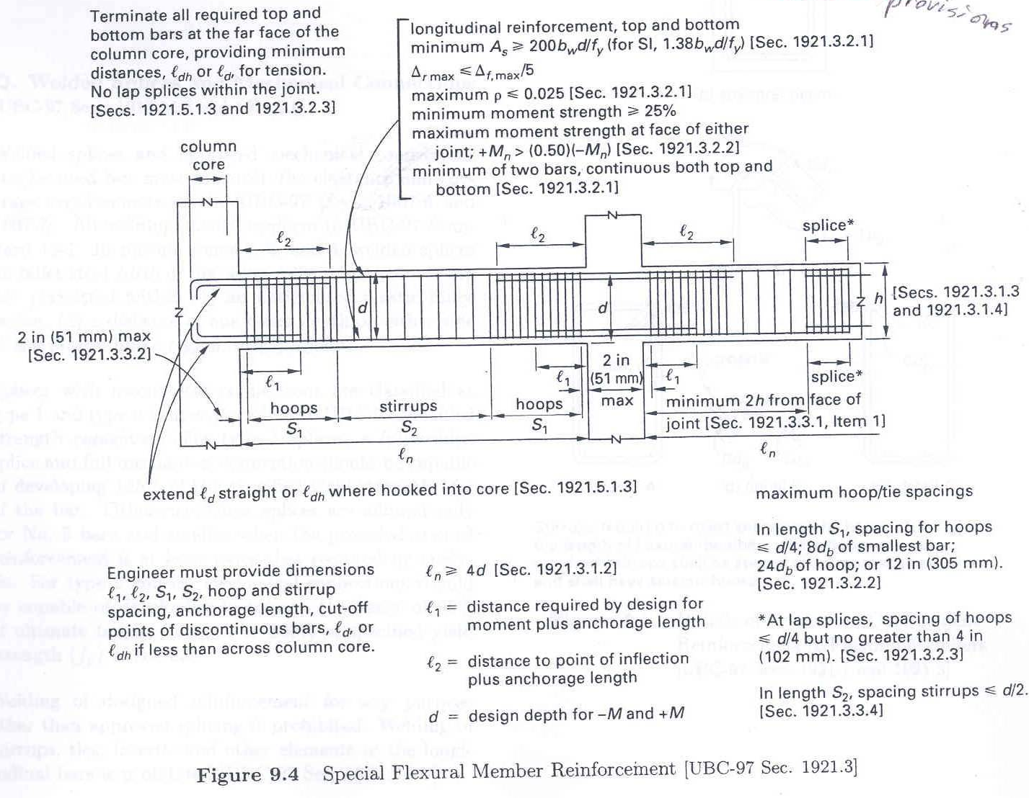
21.5.1.3]
21.3.2.3
21.3.3.2]
21.5.1.3]
21.3.1.3
[ACI 21.3.2.1]
[ACI 21.3.2.2]
21.3.2.2]
21.3.1.4]
[ACI 21.3.2.3]
(ACI Code Section 21.3)
[ACI 21.3.3.4]
21.3.3.1, Item (a)]
2 in
4d [ACI 21.3.1.2]
2
0.025 [ACI 21.3.2.1]
200
5
0.50
25% [ACI 21.3.2.2]
d/4;
8d_{b}
24
4 in
d/4
d/2
12 in [ACI 21.3.3.2]
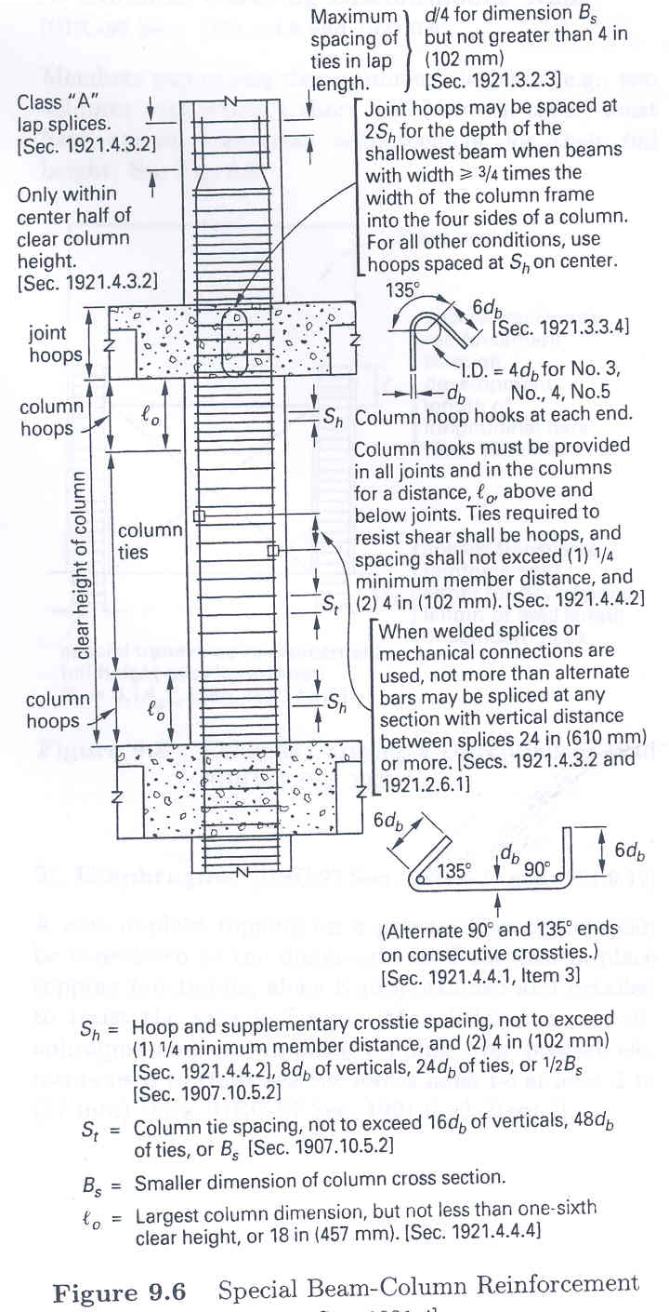
21.3.2.3]
21.4.4.2]
21.4.3.2]
7.10.5.2]
21.4.4.4]
21.2.6.1]
7.10.5.2]
21.4.3.2 and
(ACI Code Section 21.4)
1/6
18 in
16d_{b}
48d_{b}
B_{s}
48d_{b}
(1) ¼
8d_{b}
21.4.4.2]
4
90°
135°
21.4.4.1, Item (c)]
24 in
(1) ¼
6d_{b}
4d_{b}
21.4.3.2]
R21.3.3]
4
d/4
4 in
2S_{h}
> ¾

