Structural Technical Report #1
- Robert Whitaker
- Structural ~ Parfitt
- Parkview at
Bloomfield Station
- Bloomfield, NJ
- 10-05-05
By Robert Whitaker
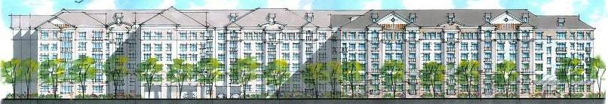
Executive summary
This report covers the structural concepts used in designing Parkview at Bloomfield Station, a six story residential apartment and parking garage in Bloomfield, New Jersey. It encompasses gravity and lateral loading analysis checks.

Structural Overview
The structural system for Parkview at Bloomfield Station is a roof composed of light gage roof trusses spaced 2’ on center (oc) spanning front to back, panelized bearing light gage walls 4” and 6” wide continuously capped with a steel tube for load distribution purposes and a 16” deep D500 Hambro® floor system. The main lateral force resisting system for the building is a shear wall system provided by thin cross bracing straps attached to the light gage bearing walls. Finally, a 4” slab-on-grade foundation with 2’-6” continuous footings makes up most of the building’s foundation; however, larger 4’x4’ spread footings are utilized below column point loads. The precast garage is structurally separate, and it will not be considered in the design review.

Code Overview
The design of the structure was in accordance with the International Building Code (IBC) 2000 with New Jersey amendments, the New Jersey Uniform Construction Code, and local county and township requirements (there were no structural changes due to these amendments). The dead, live, and wind loads used in the design were proven to be adequate based on the loadings found in ASCE 7-98 for gravity and lateral load.

Calculation Overview
All spot checks performed on structural components in the building showed that the members were adequately sized for the calculated loads. The structural columns, the Hambro floor joists, the tube steel top plates, and the shear wall assemblies were all determined to be adequately sized for both ASD and LRFD loadings. It was also determined that seismic design controlled over wind in the lateral analysis. A more in depth analysis of the lateral loadings will be conducted in Tech report 3.

Minor discrepancies with design loads were found between code dead load, snow load and live load calculations; yet, it did not appear that this had any effect on any existing member sizes. Furthermore, story drift, while not expected to be a problem, was shown to be well below the allowable limits. Summaries of the load calculations are included in the following appendix.
Structural Technical Report #1
By Robert Whitaker
- Robert Whitaker
- Structural ~ Parfitt
- Parkview at
Bloomfield Station
- Bloomfield, NJ
- 10-05-05
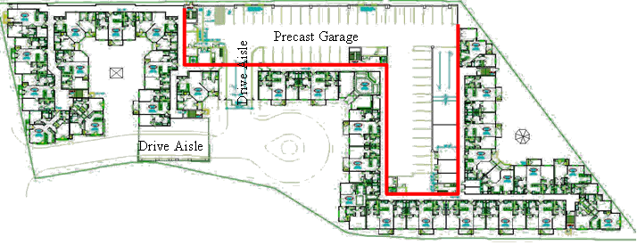

Structural Overview

The structural system for Parkview at Bloomfield Station, from the top down, is a roof composed of light gage roof trusses spaced 2’ on center (oc) spanning front to back with some hip conditions incorporated, bearing on exterior and corridor walls, and girder trusses at hip roof conditions. The bearing walls are panelized bearing light gage steel stud walls 4” and 6” wide continuously capped with a steel tube, HSS 4x4x5/16” and HSS 6x4x5/16” respectively, for load distribution purposes. Beams and transfer beams also make up bearing points for the floor system, columns, and roof trusses. Interior non-bearing walls are light gage infill walls to be assembled after the main structure is built. A 16” deep Hambro® D500™ floor system makes up the rigid floor diaphragm and consists of joists spaced at 4’ oc connected to a 3” concrete floor (3000psi). The 16” joists span the short direction of the living units (typically 30’) and Hambro RTC joists (top cord only joists) span the corridor (6’ typical).

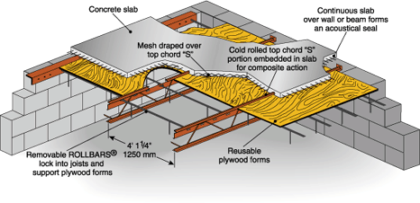
The Hambro® D500™ composite floor joist system is an advanced up-to-date answer to elevated floor construction challenges. Combining Hambro steel joists with poured concrete, the system consists of hybrid concrete/steel T-beams running in one direction and an integrated continuous slab in the other. The bottom chord (Fy = 50,000psi min.) acts as a tension member in the concreting stage and during the service life of the floor. The web system tying top and bottom chords consist of bent rods (Fy = 44,000psi min.) and together resist vertical shear in a conventional truss manner. The patented 13 gage top chord (Fy = 50,000psi min.) acts as a compression member during the non-composite stage. In the composite stage, the top chord includes an “S” shape that is embedded in the concrete and functions as a continuous shear connector. The concrete slab is supported during the pour by reusable plywood panel forms located between joists and braced by ROLLBARS® that are held in place by holes in the top chord of the joist. The concrete slab is reinforced with 6x6 welded wire mesh. The “S” on the top chord functions as a high chair for this wire mesh, developing the negative moment capacity in the for the composite system which behaves as a continuous one-way reinforced slab over the joists. The 4’-1¼” joist spacing is based on the standard dimensions of a plywood panel. This method of formwork replaces the need for metal form deck or scaffolding and creates a quicker erection time. The time savings and reuse of the plywood forms reduces the overall cost of the system.
Hambro Floor System
Note: Typical bearing walls are light gage walls (not those shown above)
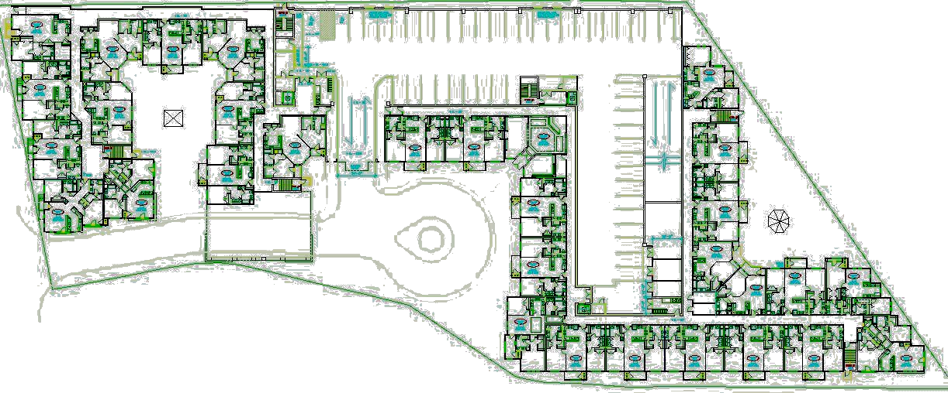
Precast Garage (not included)
Drive Aisle
Drive Aisle
Along with the bearing light gage walls, there are two drive aisles that pass under the building. The upper floors in these sections are supported by a series of one or two story columns as part of a W-shape cross bracing system. All 6 floors have mainly the same floor plans with the exception of 4 locations: an entry/lobby unit, a 2 story drive aisle, a 1 story drive aisle, and a 1st floor exit route. In these areas transfer beams are utilized creating much larger beam sizes. A two story braced frame system is utilized in the 2 story drive aisle, consisting of 18 columns placed along bearing lines. There is a similar system at the one story drive aisle consisting of 12 columns. While this braced frame acts as the lateral force resisting system in these two unique areas, the main lateral force resisting system for the building is a shear wall system provided by thin steel cross bracing straps attached to the light gage shear walls.

The columns in the building are hollow steel shapes and vary in size depending on capacity needed and depth required to fit into the wall systems. The 30 columns in the drive aisles are W-shapes and have a much larger capacity. The majority of the columns are HSS 3x3x1/4” and this size usually enlarges on the lower 3 floors with the exception of the 4 unique areas mentioned.
Tube Steel columns Fy = 46ksi ~ ASD
Column Size | Capacity | Column Size | Capacity
HSS 3x3x1/4” | 35.5 k | HSS 6x3x1/4” | 63.5 k
HSS 4x4x1/4” | 67.5 k | HSS 7x3x3/8” | 90.0 k
HSS 5x5x1/4” | 98.0 k | W14x74 (22’) | 405.0 k
HSS 5x5x1/2” | 173.5 k | Column height = | 9’-6”

Concrete Strength
Type or location of concrete | Min comp. strength F’c at 28 days for severe exposure | Minimum slump
Foundations not exposed to weather and interior slabs-on-grade | 3000psi | 4 + 1
Driveways, patios, porches, steps and other flatwork exposed to the weather | 3500psi | 4 + 1
Finally, continuous 2’-6” wide footings make up most of the building bearing wall support under the 4” slab-on-grade foundation. However, larger spread footings (typically 4’x4’) are utilized below column point loads, and at the garage entrances. The precast garage's footings are separate from that of the main building.

The precast garage at the center of the building consists of precast double-T planks spanning a maximum of 60’. These planks bear on 10” precast wall components, load bearing CMU stair walls, or precast spandrel beams. The spandrel beams are picked up by 24”x32” columns located around the perimeter of the parking garage. The vertical elements transfer their load to pile caps encompassing 100 ton H piles, drilled to bedrock (ranging from 42-53 ft below the slab-on-grade surface). The precast garage is structurally separated from the main building by a 4” air gap and by 4” expansion joints at building connection points and will not be considered in this building analysis.

Design Theory

The design theory used in the analysis of Parkview at Bloomfield Station was Allowable Stress Design (ASD). The beam calculations were designed to American Institute of Steel Construction (AISC) 9th Edition ~ ASD and designed using the Enercalc® program (ASD based). The tube steel columns were also designed based on the column tables in chapter 3 of the AISC 9th Edition ~ ASD.

The spot check of the building is based on Load and Resistance Factor Design (LRFD) and the use of design aids from the American Institute of Steel Construction (AISC) 3rd Edition ~ LRFD manual. The difference in design theory (LRFD v. ASD) will change the overall loads calculated as compared to the ASD design calculations, but should yield equal sized members or members that are slightly smaller than those designed. In some unique situations, however, the member sizes might increase due to the use of LRFD design theory. One such area will be in the corridor areas because of the 1.6 LL factor’s contribution on the 100psf live load; the load in this area grows disproportionately with the factor of safety from ASD.

Code References

The design of the structure was in accordance with the International Building Code (IBC) 2000 with New Jersey amendments, the New Jersey Uniform Construction Code, and local county and township requirements. IBC 2000 used design loads specified in ASCE 7 for both gravity and lateral loadings. Furthermore, the New Jersey amendments to IBC 2000 did not create any changes to the structural code requirements of IBC 2000, but focused more on non-structural issues throughout the code. In addition, no changes to the structural design requirements were added by the NJ Uniform Construction Code or any of the local requirements.

Gravity Design loads IBC 2000 NJ ~ ASCE 7
Location | Live Load | Dead Load | Total Load | Wall Type | Live Load | Dead Load | Wall Height | Total Load
Roof | 40psf | 17psf | 57psf | Single Light Gage Wall | - | 11psf | 9’-6” | 105plf
Unit/Balcony | 40psf | 45psf | 85psf | Double Light Gage Wall | - | 15psf | 9’-6” | 143plf
Corridor | 100psf | 45psf | 145psf | 8” CMU Wall | - | 60psf | 9’-6” | 570plf
Storage | 125psf | 45psf | 170psf
The live loads used in the spot check were taken from ASCE-7 Table 4-1, and correspond with the deign loads. The only exception is the roof loading where calculations showed that 20psf should have been the design load, but the original designers added 10psf on the top and bottom chord of the roof trusses. The additional 10psf on the top chord was added to account for snow drift and the 10psf added to the bottom chord accounts for any light attic storage.

The design dead loads listed above differed from my dead loads calculated with ASCE-7 Table 3-1. The dead load including superimposed loads from floor finishes, ceiling materials, mechanical equipment, and partition walls in addition to the self weight came out to be 57psf, 12psf greater than that used in the design. It was seen in the spot check calculations that this difference did not lead to any changes from the initial sizes, and that the 65psf dead load used in the Hambro calculation was more than adequate for the design.

Since Bloomfield, NJ is located at the center of an east coast seismic epicenter, seismic has a much larger effect on the lateral analysis. Similarly, Bloomfield is located near the coast line, so it also experiences greater wind speeds (basic wind speed of 110 mph). It was determined that the effects of seismic loading, while close to the loading incurred by wind, created larger forces to be resisted in the shear walls.
Snow and lateral load overview

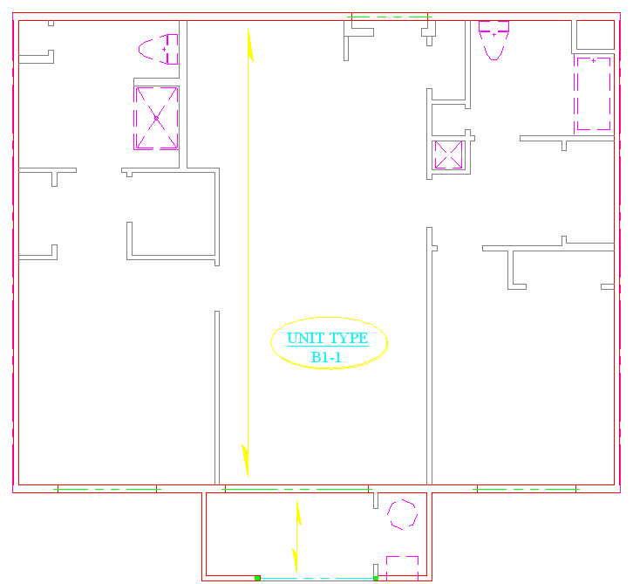
Typical Unit Floor Framing - Spot Check
30’-0” Typical
Hambro framing direction
5’-6”
Deck
Corridor

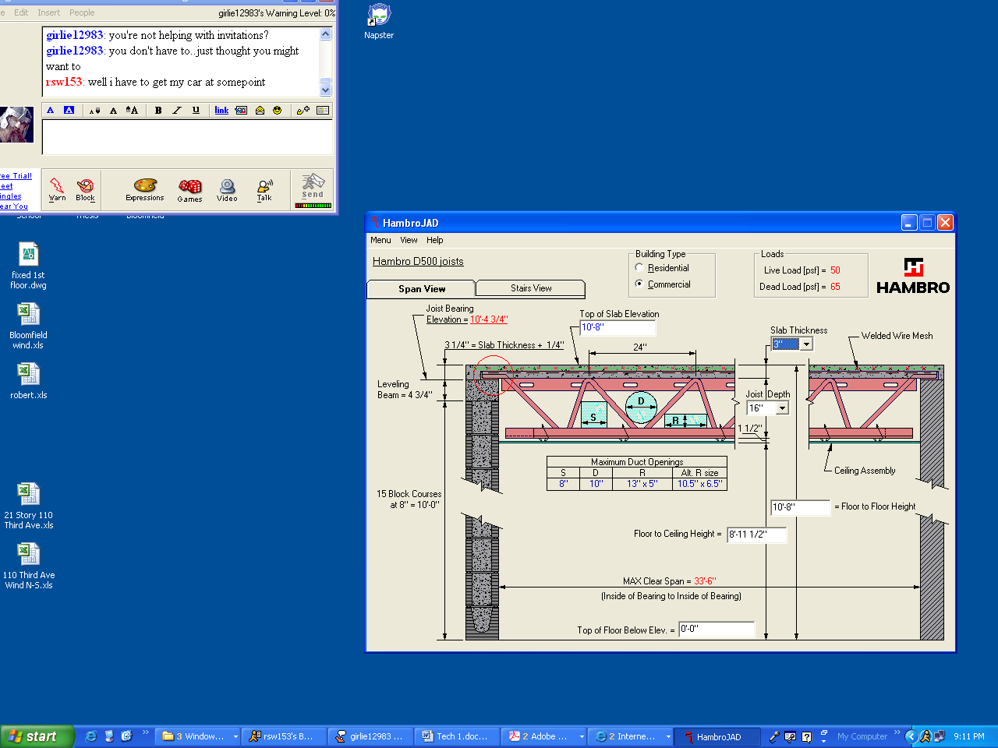

The floor framing throughout the building spans from the exterior wall to the corridor wall (typically 30’-0” + 1’-0”), and then framing in the corridor, Hambro RTC, which is capable of holding the 100psf live load for spans up to 8’-0”, spans from the corridor wall to the exterior corridor wall (Typically 6’). The floor framing acts as simple span beams back to back through the unit and corridor, but the concrete flooring is continuous indefinitely in the direction perpendicular to the joists. This creates composite action and continuity between the units.
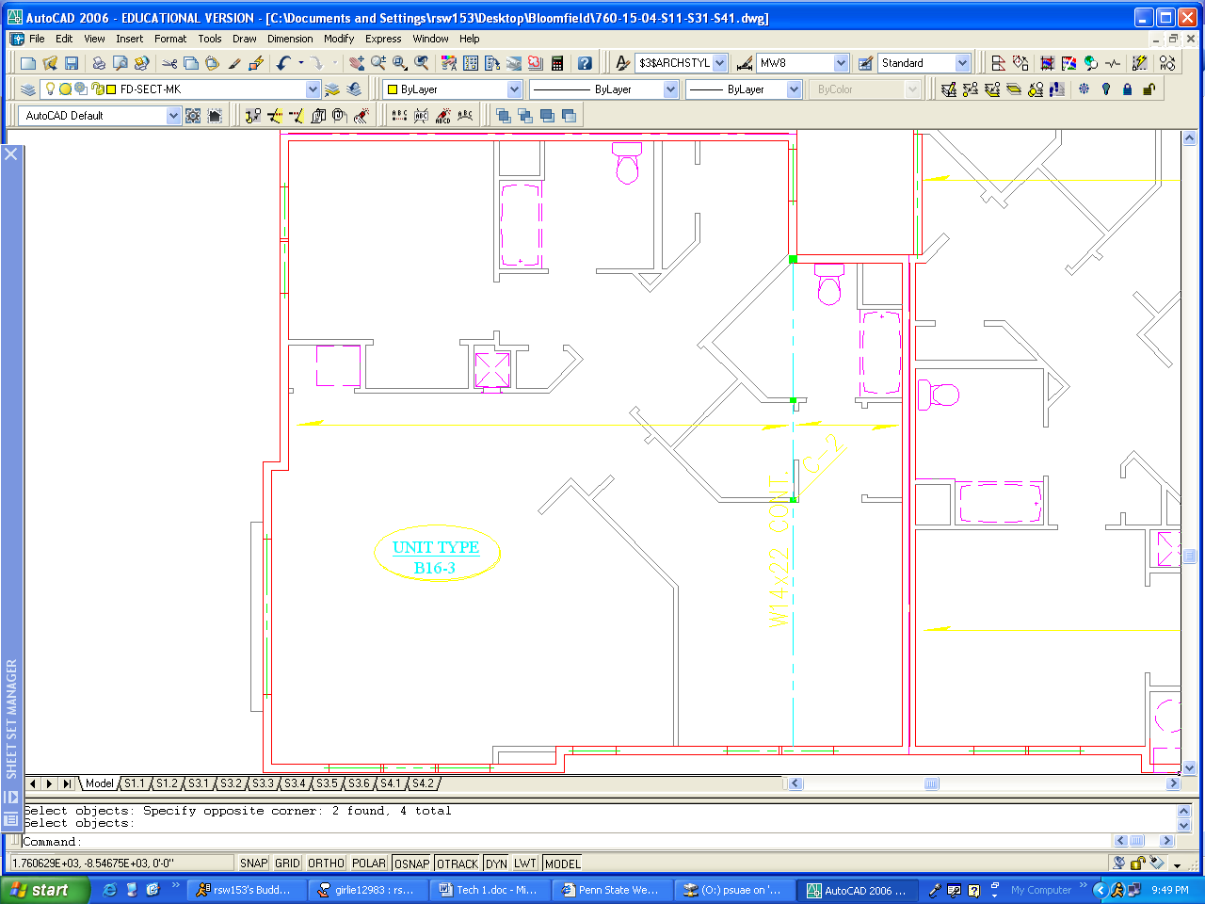
18’-0”19’-0”

9’-0”
HSS 4x4x1/4”
(Typical)
12”14’-9” 5’-9” 8’-3” 7’-3”

30’-9” 6’-9”
Corner Unit

Floor Framing Check

As seen in the typical unit B1-1, the 30’-0” spacing falls below the 33’-6” max allowed for 16” Hambro joists with 3” concrete slab thickness calculated on the previous page. At the corner unit B16-3, the span is 9” longer but still fulfills the 33’-6” max requirement. The loads used in Hambro’s design program exceed the actual 57psf DL and 40psf LL, further adding to the confidence of this floor system design.

Column Comparisons

The columns were designed under ASD loading cases; however, this check was performed using the LRFD 3rd Edition design manual.
Design Sizes
Tube Steel columns Fy = 46ksi ~ ASD
Column Size | Capacity | Column Size | Capacity
HSS 3x3x1/4” | 35.5 k | HSS 6x3x1/4” | 63.5 k
HSS 4x4x1/4” | 67.5 k | HSS 7x3x3/8” | 90.0 k
HSS 5x5x1/4” | 98.0 k
HSS 5x5x1/2” | 173.5 k | Column height = | 9’-6”

My Sizes
Tube Steel columns Fy = 46ksi ~ LRFD
Column Size | Capacity | Column Size | Capacity
HSS 3x3x1/4” | 47.0 k | HSS 6x3x1/4” | 83.5 k
HSS 4x4x1/4” | 90.2 k | HSS 7x3x3/8” | 117.0 k
HSS 5x5x1/4” | 133.0 k
HSS 5x5x1/2” | 236.5 k | Column height = | 9’-6”

It was determined that the column LRFD capacities are all ≈ 1.3 times the ASD values. I then checked to see if the design is the same for both code sources; I checked what the loads change by:

Load Increase Factor ≈ 0.9*(1.2*45+1.6*40)/(45+40) = 1.25 < 1.3

Therefore, the load combinations and phi factors caused increases by about the same amount as the conversion from ASD to LRFD capacity allowances. This means that the column design yields the same sizes or slightly smaller sizes with both ASD and LRFD methods, as should be the case.

Top Plates

Checking the HSS 4”x4”x5/16”distribution top plate using LRFD

Wall opening = 9’-0”
V_{allow} = 101.8 k > 8.16 k actual
M_{allow} = 19.3 ‘k > 18.33 ‘k actual
Actual Δ_{LL} = 0.076” < L/360 = 0.3”
Actual Δ_{TL} = 0.166” < L/180 = 0.6”

Since all cases check out to be ok, I have concluded that the HSS 4”x4”x5/16” and by inspection the HSS 6”x4”x5/16” top plates are accurately designed for the loads that they will be exposed to.

W14x22 Continuous Beam

The beam was checked using Enercalc software and was shown to pass under all cases including pattern loading. See Appendix sheet 2c.
Snow Load

Ps = Cs*Pf = 0.9 * 21psf = 18.9psf < 20*Is = 20psf as compared to a sloped roof design load of 21psf.

Equation | Result | Code Reference  (ASCE 7 – 98) | Design Value
Ps = Cs*Pf = 0.9*21psf = | 18.9 < 20*Is => 20psf | ASCE 7.3 | 21psf
Pf = 0.7*Ce*Ct*I*Pg = | 21psf | Eq. 7-1 | 21psf
Ce = | 1.0 | Table 7-2 | 0.8
Ct = | 1.0 | Table 7-3 | 1.1
Is = | 1.0 | Table 7-4 | 1.0
Roof slope (8:12)= | 37.7° | Category II | 37.7°
Pg = | 30psf | Fig. 7-1 | 30psf
Cs = | 0.9 | Fig. 7-2 | 1.0

Design Values
Wind and lateral load overview
My calculated load was 20psf as compared to the 21psf the building designed utilized. The difference in calculations were not major differences, but it appeared that the designers used a Ct of 1.1 assuming “structures kept just above freezing and others with cold, ventilated roofs in which thermal resistance between the ventilated space and the heated space exceeds 25 F*h*ft^2/Btu.” I obtained my value of 1.0 for Ct using “all structures except as indicated below”. This difference accounts for the difference in the Cs factor because this value is based on Ct.

The value for Ce that I used in my calculations was based on my selection of a terrain category B, partially exposed site. The design value used was based on terrain category D, fully exposed site. The value used in the actual design appears to be based on the most conservative but still reasonable values found in the code. Even with the use of these values the total design snow load only has a difference of 1psf from the 20psf that I calculated. However, the live load listed for the roof loading was 40psf accounting for 10psf of drift and 10psf for light attic loading.

Wind Analysis
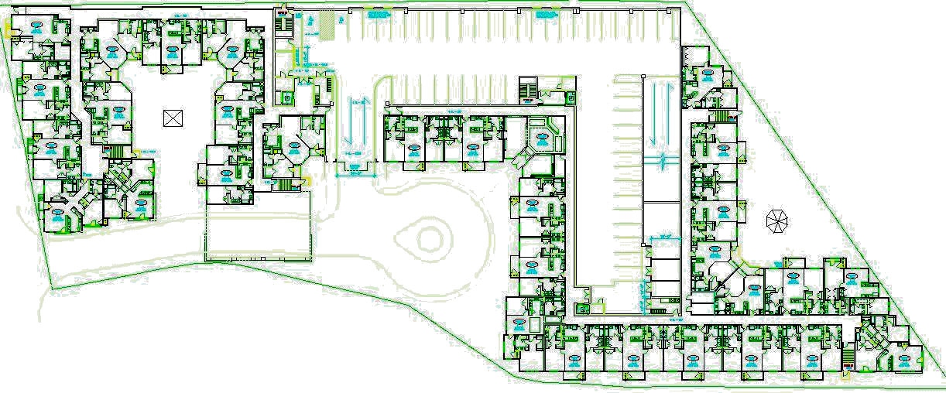
Precast Garage
Drive Aisle
Building information
N-S direction: Shear walls
E-W direction: Shear walls
Locations: Bloomfield, NJ
Exposure: B
Building use: Residential

24.7’ 6’ Corridor
Shear Wall A-A

Shear Wall

Shear Wall

30’ Unit Unit
6 stories
@ 10’-8”
= 64’-0”
2 units @ 38’ = 76’
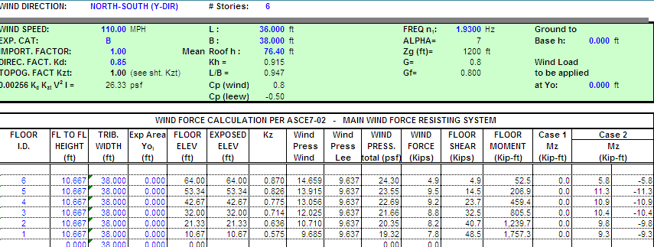
Section @ Shear Wall A-A Plan at Shear Wall

(Same results on the E-W shear wall)
The loading on the diagram (right) represents the loading on a single shear wall in the building. These loads are compared with those calculated in the following seismic section, and the overall larger of the 2 loading sets will be used in the design of the shear wall system. This was initially how the design of the system was carried out. The design specified exposure class D which is conservative, and does not correspond with the recommendations of the Geo-tech report for exposure B. This makes the design values more conservative and is the only area of difference.
RF
5
4
3
2
1

48.5 k
4.9 k
9.5 k
9.2 k
8.8 k
8.2 k
7.8 k

Section @ Shear Wall A-A
Windward Leeward
Seismic Analysis

RF
5
4
3
2
1

60.4 kips
6.7 k
18.2 k
14.4 k
10.7 k
7.0 k
3.4 k

Section @ Shear Wall A-A
RF
5
4
3
2
1

27.4’

64’-0”

Building Dimensions
RF
5
4
3
2
1

V_{b}=1088 kips
119.7 k
327.5 k
260.0 k
192.6 k
126.2 k
62.0 k

Total Shear on Building Section

There are 18 shear walls in the N-S direction and 20 shear walls in the E-W direction (see next page for shear wall locations). Therefore, the critical direction is the N-S direction, and an individual shear wall needs to have 1/18th the capacity of the total floor shear, resulting in the loading shown on the diagram of section A-A. In reality there may be some walls that carry more than 1/18th of the total floor shear due to distribution, but this will be ignored until Tech 3. With the individual shear wall loads computed, it is evident that seismic loading will control the design of the shear walls (60.4 k seismic > 48.5 k wind).
Floor | W_{x}h_{x}^1.039 | Cvx | Fx=Cvx*Vb | Fx/18
Roof | 63,339.6 | 0.110 | 119.7 k | 6.7 k
5 | 172,697.4 | 0.301 | 327.5 k | 18.2 k
4 | 136,960.8 | 0.239 | 260.0 k | 14.4 k
3 | 101,574.6 | 0.177 | 192.6 k | 10.7 k
2 | 66,654.0 | 0.116 | 126.2 k | 7.0 k
1 | 32,438.1 | 0.057 | 62.0 k | 3.4 k
sum | 573,664.5 | 1.000 | 1088.0 k | 60.4k

Design loads
Lateral Load Overview

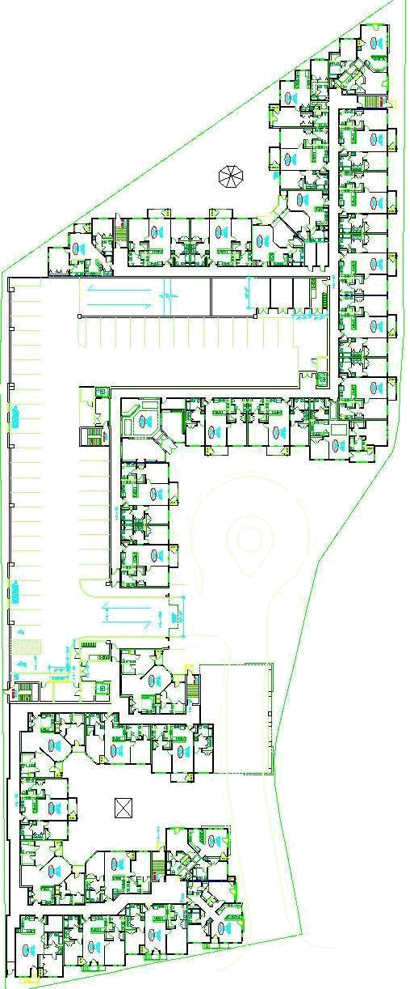
Precast Garage
Drive Aisle
Drive Aisle
Shear Wall Locations

Shear Wall Design
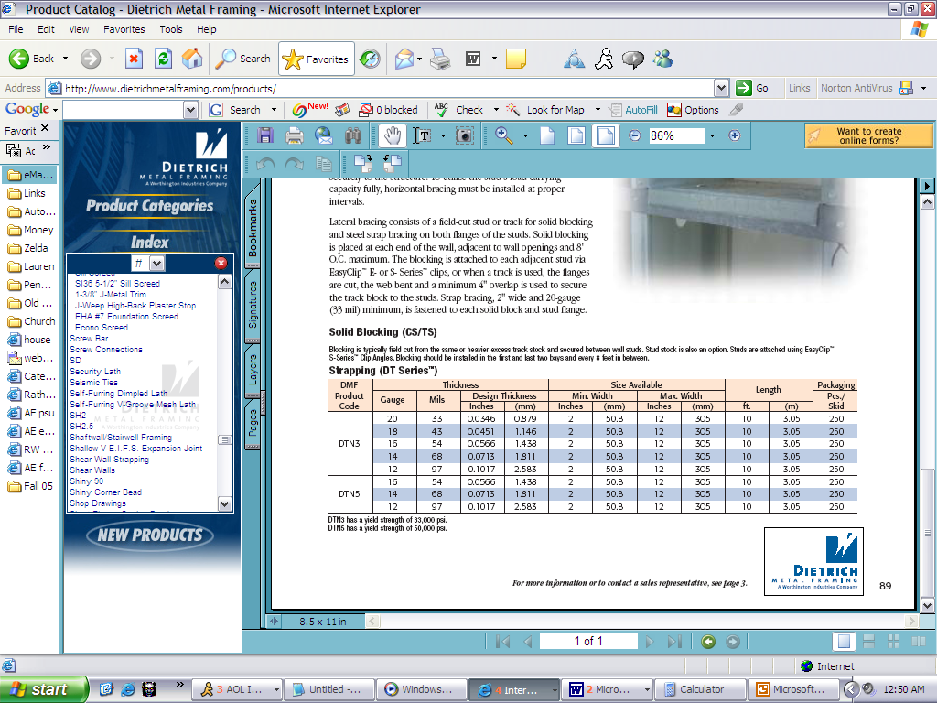
FloorStrap SizeP _{Allow}P _{Actual}RFDTN5 4” 12 gage 9.8 k 6.7 k5DTN5 6” 12 gage29.2 k24.9 k4DTN5 10” 12 gage48.6 k39.3 k3DTN5 12” 12 gage50.8 k50.0 k2DTN5 12” 12 gage58.3 k57.0 k1DTN5 12” 12 gage DTN5 4” 12 gage68.1 k60.4 k
www.dietrichmetalframing.com
30’-0” + 1’-0”
9’-6”

A converted tensile capacity based on the allowable axial tension of a 12 Gage 12” wide shear cross bracing strap raised at a 17º angle from the floor is used to check the shear straps at the lowest level. The strap allows a tensile load of P_{allow} = A_{s}*F_{y}*cos θ = (12”*0.1017)*50ksi*cos 17º = 58.3 k < 60.4 k therefore it is not ok for the lowest floor but ok for the 2nd floor. An additional 4” strap will need to be added at the lowest floor making P_{allow} = [(12”+4”)*0.1017]*50ksi*cos 17º = 68.1 k > 60.4 k which is now ok.

Using the same approach, the shear cross bracing strap sizes for the other floors is determined and is listed on the chart above. These sizes are similar to the design sizes for the shear walls, but generally smaller. The difference is accounted for in the fact that more walls were used as shear walls in the design and also a dynamic analysis was conducted for the seismic design rather than the simplified procedure I used.

Story Drift (deflection at the base floor):

h/L=9.5’/30’= 0.316
K = (Et)/[4(h/L)^3+2.78(h/L)] = 129890 k/in
I = t*L^3/12 = [4.5” * (30’*12)^3]/12 = 17496000 in^4
Δ = Ph³ + 2.78Ph = 60.4k * (9.5’*12) ³+ 2.78 * 60.4k*9.5’*12 . = 0.00046”
3EI A_{w}E 3*29000ksi*I 4.5”*30’*12*29000ksi
H/400 = 9.5’*12/400 = 0.285” > 0.00046” therefore ok
Spot Check Overview

All spot checks performed on structural components in the building showed that the members were adequately sized for the calculated loads. The structural columns, the Hambro floor joists, the tube steel top plates, and the shear wall assemblies were all determined to be adequately sized for both ASD and LRFD loadings. It was also determined that seismic design controlled over wind in the lateral analysis. A more in depth analysis of the lateral loadings will be conducted in Tech report 3.

While minor discrepancies with the design loads were found between my dead load, snow load and live load calculations, it did not appear that this had any effect on any existing member size. Furthermore, story drift, while not expected to be a problem, was shown to be well below the allowable limits. Summaries of the load calculations are included in the following appendix.
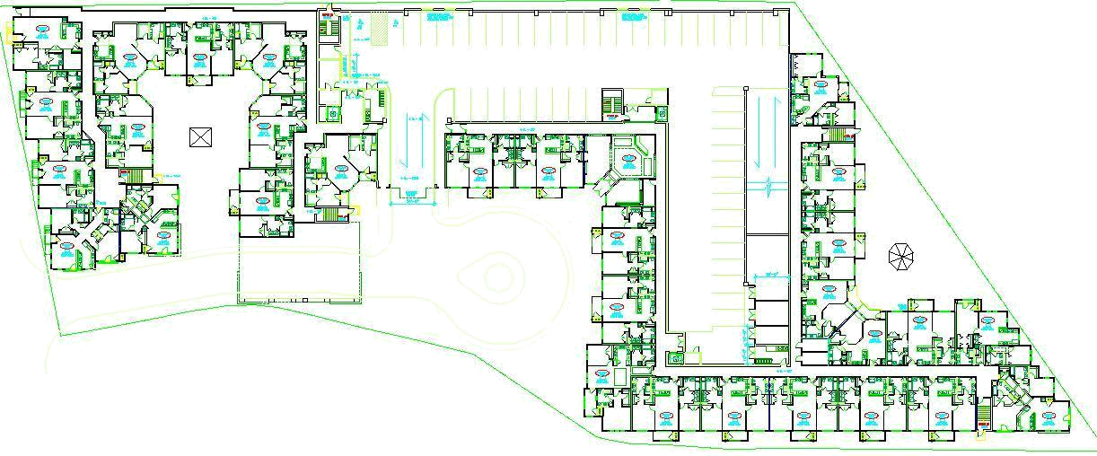
Precast Garage
Drive Aisle
Drive Aisle

http://www.hambro.ws/
ASCE 7 Ch 7
I have not yet learned all the aspects of this code; see Tech 3 for a more complete analysis of the building’s wind and dynamic seismic loading.
I have not yet learned all the aspects of this code; see Tech 3 for a more complete analysis of the building’s wind and dynamic seismic loading.

