Structural Technical Report #2
- Robert Whitaker
- Structural ~ Parfitt
- Parkview at
Bloomfield Station
- Bloomfield, NJ
- 10-31-05
By Robert Whitaker

Executive Summary

This report covers the comparative redesign of the Hambro® floor system currently used in Parkview at Bloomfield Station, a six story residential apartment in Bloomfield, New Jersey. This comparison encompasses gravity loading analysis for five different floor systems: bar joist with metal decking, hollow core planks, concrete pan joists, waffle flat slab and pre-stress concrete slab. There is a comparison table and an extensive calculation appendix attached at the end of this report.

The typical design bay size in Parkview is 30’-0” + 1’-0” wide by 38’-0” long. There are no height restrictions for the building but a shorter height is desirable with a current ceiling-to-floor depth of 19”. This ceiling-to-floor depth allows for six residential levels and a roof level with a total building height of just less than 89 feet. The Hambro System has a 3 hour fire rating and a low system weight of 40 pounds per square foot. This system also features a quick erection time, creating a lower overall floor system cost.

The best floor redesign to parallel the Hambro system is the hollow core plank floor system. The hollow care plank systems features shorter depths (10” + 3”to 6”), and a fast erection time. The hollow core plank system is also a less complex option overall and reasonably close in cost to the Hambro system. However, a change in supporting structure from lightgage shear walls to a steel or concrete lateral frame will be required, causing some changes to the existing architecture. This system has system weights nearly double the current floor weight, and will require larger foundations. Finally, additional fireproofing will need to be considered for the hollow core plank system which only has a 2 hour fire rating. While this floor system has drawbacks with respect to weight and support system, the hollow core plank system appears to be the most viable alternative to the current floor system.

Structural Technical Report #2
By Robert Whitaker
- Robert Whitaker
- Structural ~ Parfitt
- Parkview at
Bloomfield Station
- Bloomfield, NJ
- 10-31-05
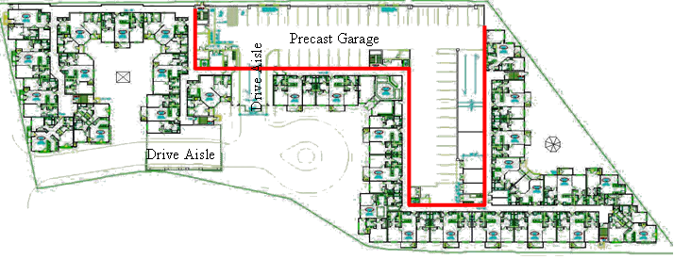

Structural Overview

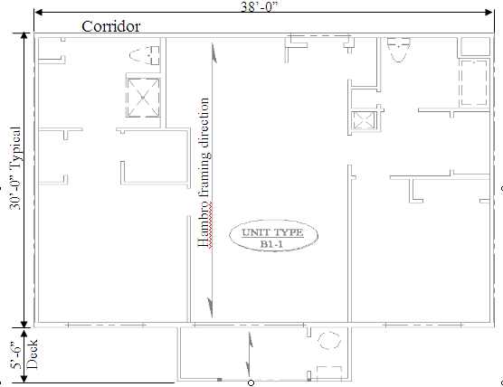
Parkview at Bloomfield Station, a six story residential apartment building located in Bloomfield, New Jersey has a floor system design that consists of 16” Hambro® composite bar joists spaced at 4’-0” on center (oc). The precast parking garage, structurally separate from the main building, is not considered in the floor redesign. All six floors stack vertically, with the exception of the two drive aisle locations and the two entry units. Theses areas have the same basic framing elements but the bearing locations have been changed to accommodate the architectural features. The floor loading is the same for all six levels and consists of 40 pounds per square foot (psf) live load (LL) in the residential sections, and 100 psf live load for the corridor and public spaces such as the lobby and gym.
Typical Unit

The typical unit also has an additional 18 psf of dead load (DL) due to the suspended gypsum wall board ceiling, mechanical units and ductwork feeding the apartment, partition walls, and floor finishes. The floor is finished with carpet in the living room, hallways and bedrooms, and finished with tile and wood in the bathroom and kitchen areas with wood flooring at the main entry.

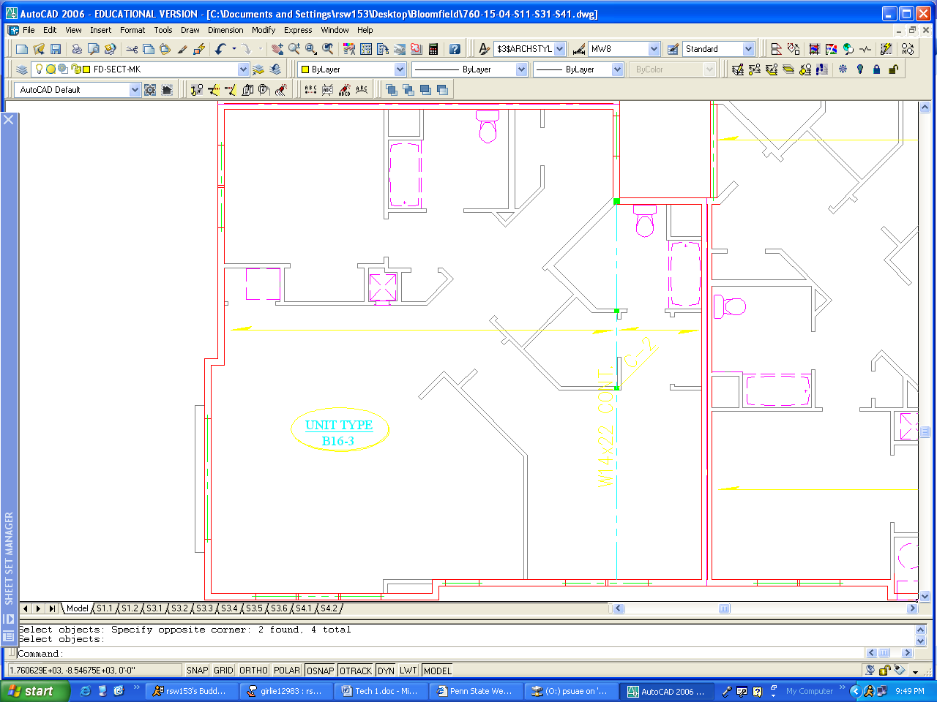
18’-0”19’-0”

9’-0”
HSS 4x4x1/4”
(Typical)
12”14’-9” 5’-9” 8’-3” 7’-3”

Living Room
Bedroom
Master Bedroom
Bathroom
Bathroom
Kitchen Area
Entry
Corridor
Corner Unit

30’-9” 6’-9”

Existing Floor Framing

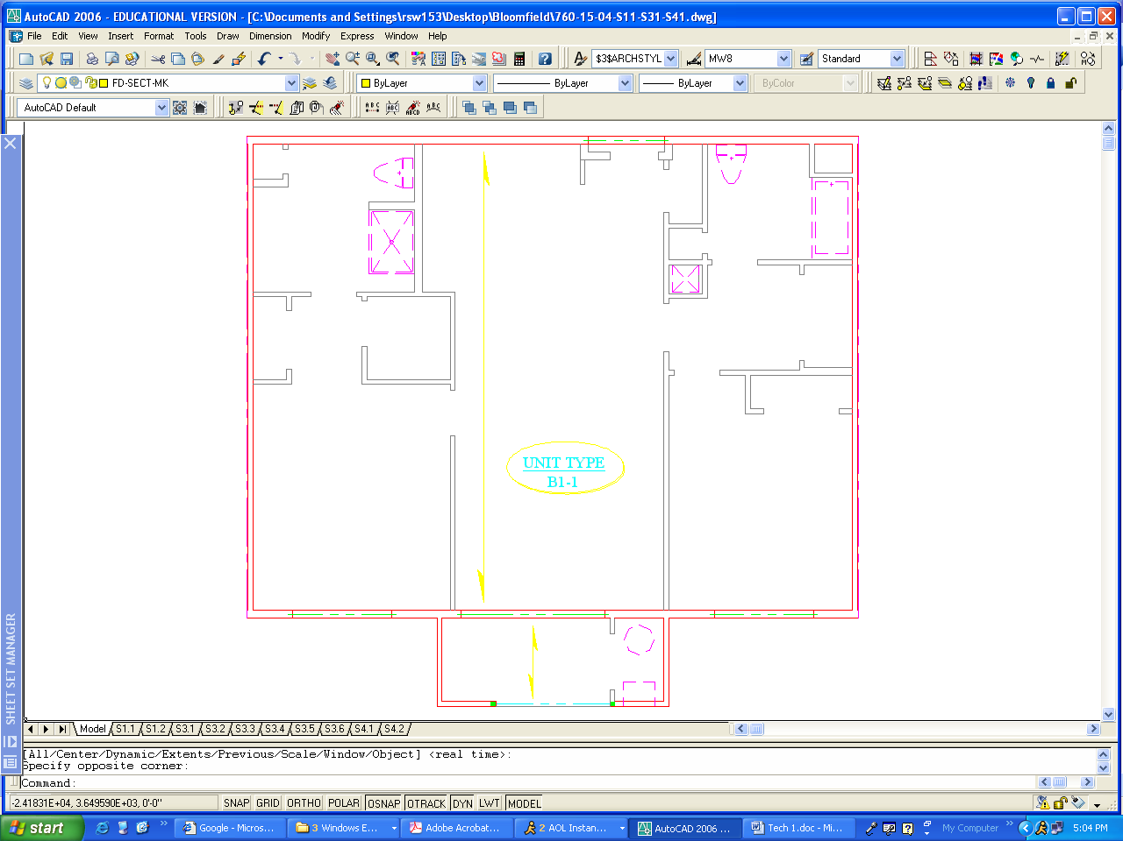
The current floor framing at Parkview at Bloomfield Station spans from the exterior wall to the corridor wall (typically 30’-0” + 1’-0”), and the framing in the corridor spans from the corridor wall to the exterior corridor wall (typically 6’). Sixteen inch Hambro joists at 48” oc with 3” topping compose the main floor framing (depth = 19”). Hambro RTC, top cord only members which are capable of holding a 100 psf live load for spans up to 8’-0”, frame out the corridor and deck.
30’-0” + 1’-0” Typical
Hambro framing direction
5’-6”
Deck
Corridor
38’-0”

The Hambro floor system has a system weight of 40 psf based on the 3” thick concrete floor and the joist weight over the 4’-0” spacing. Because of the 3” thick concrete flooring, and the non-combustible nature of the steel, this system has a fire rating of 3 hrs based on Underwriter Laboratories (UL) testing. This 3 hour rating was one of the original reasons for the selection of Hambro joists as the flooring system, reducing the number of firewalls in the building.

Furthermore, since the formwork for the slab is built into the joists, the need for labor decreases and the overall cost of the system is greatly reduced. This system is very durable and only has problems, like most steel and concrete structures, when exposed to water or large temperature changes. Since this system is primarily an interior system, it should last as long as the building’s life. This system also performs well in vibration and sound transmission; it has an Impact Isolation Class (IIC) of 30 and a Sound Transmission Class (STC) of 57.
Alternate Floor Framing

The redesign of the flooring system at Parkview at Bloomfield Station encompasses gravity loading analysis for five different floor systems: bar joist with metal decking, hollow core planks, concrete pan joists, waffle flat slab, and pre-stressed concrete slab. These floor assemblies were then compared to determine which one provides the best solution for the building’s floor system.

Alternate Floor Framing Option #1

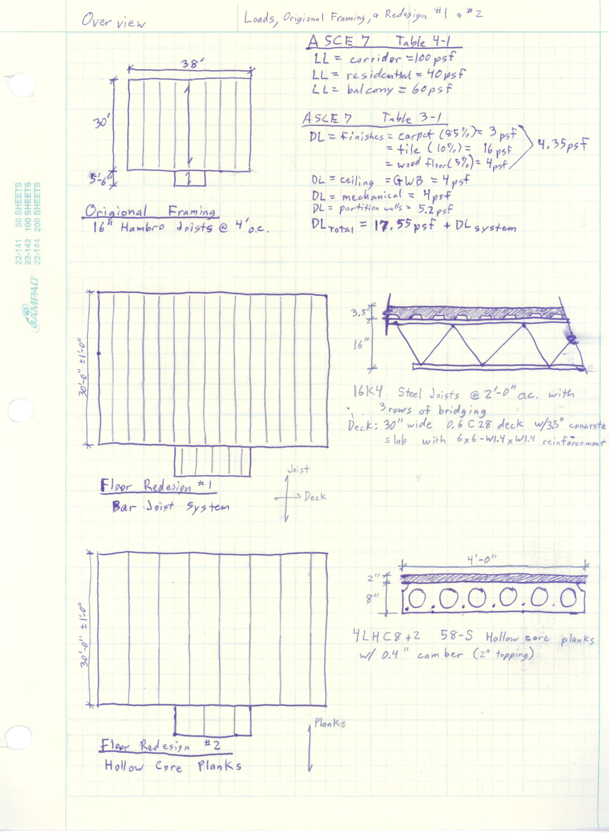
The first floor redesign is looking into the impact of making the flooring system out of non-composite bar joists and metal decking. The 16” inch steel bar joists spaced at 24” oc with a 3½” concrete and metal deck system provides a comparison to the original floor system with a similar 19½” depth and a 3 hour fire rating. This system will not require any architectural changes because it is also able to use the same support system, lightgage steel walls, as the original Hambro joist system.

The bar joist system utilizes 16K4 steel joists at 2’-0” oc with 3 rows of bridging and 30” wide 0.6C28 deck. The bar joist system also employs a 3.5” concrete slab with 6x6-W1.4xW1.4 welded wire fabric as slab reinforcement. This system has a similar erection time to the Hambro arrangement but is more expensive due to the increased amount of material and time required to install twice as many joists. Moreover, the system weight is 48 psf, which is 8 psf heavier than the original design. Lastly, this new design should have approximately the same vibration and noise coefficient results as the current system. This is because sacrificing the system’s rigidity by becoming non-composite is made up for by using twice as many joists. This system, though it will also last the life of the building, does not have any benefits beyond the existing Hambro system to lead to a more extensive analysis.
Alternate Floor Framing Option #2

The second floor redesign is the use of 8” hollow core planks with 2” concrete topping, which is much thinner than the existing 19” system. The mechanical ductwork would need to be attached to the bottom of the panels adding 3”-6” to the system, unlike the current system where the ducts just pass through the web openings.

This system, while thinner overall, has a system weight of 81 psf, double that of the Hambro system. Because of this added weight and the required bearing length, the support system needs to be either a concrete frame or a W-shape steel frame. Both of these support systems affect the architectural layout of the apartment by requiring wall bump-outs at the column locations. This will also increase the required footing sizes and change the lateral resisting elements from shear walls to braced frames with lightgage infill.

The overall cost of the hollow core plank system is comparative to the Hambro system due to its quick erection time and reduced on site labor requirement due to its precast nature. Having a fire rating of only 2 hours, this system is the lowest rated assembly analyzed and will need to have additional fireproofing added. However, it does have comparable IIC and STC to that in the Hambro system with values of 38 and 58 respectively. The reduction of ceiling-to-floor height will allow the building to have either higher finished ceilings or reduced building height by nearly 2 feet. Like the other designs, this system will last for the life of the building. While this floor system has its drawbacks with respect to weight and fireproofing, it appears to be a very viable alternative to the current floor system.
Alternate Floor Framing Option #3

The third floor redesign is a concrete pan joist system. It utilizes a 30” pan with 6” joists, and an overall depth of 19”. This depth equals the depth of the existing Hambro system but has some drawbacks associated with it. First, the Hambro system allows for easy access of ductwork through the system, yet for this system, concrete would need to be removed from certain areas, greatly increasing system costs and creating a weaker overall system. To avoid this complication the duct work could be placed below the system but at the cost of a much deeper system, 22” or more.

Additionally, this system has a system weight of 78 psf, nearly double the existing system, and therefore requires a larger support and foundation system. Since the floor system will be completely concrete, the lightgage bearing walls will not suffice due to material interactions and strength considerations. A concrete beam and column system will need to be introduced as the gravity and lateral load carrying element, affecting the existing architectural layout by requiring bump-outs at column locations. Finally, the cost of the system is greatly increased due to the time needed to place the concrete column forms and for the even placement of the pans along the span.

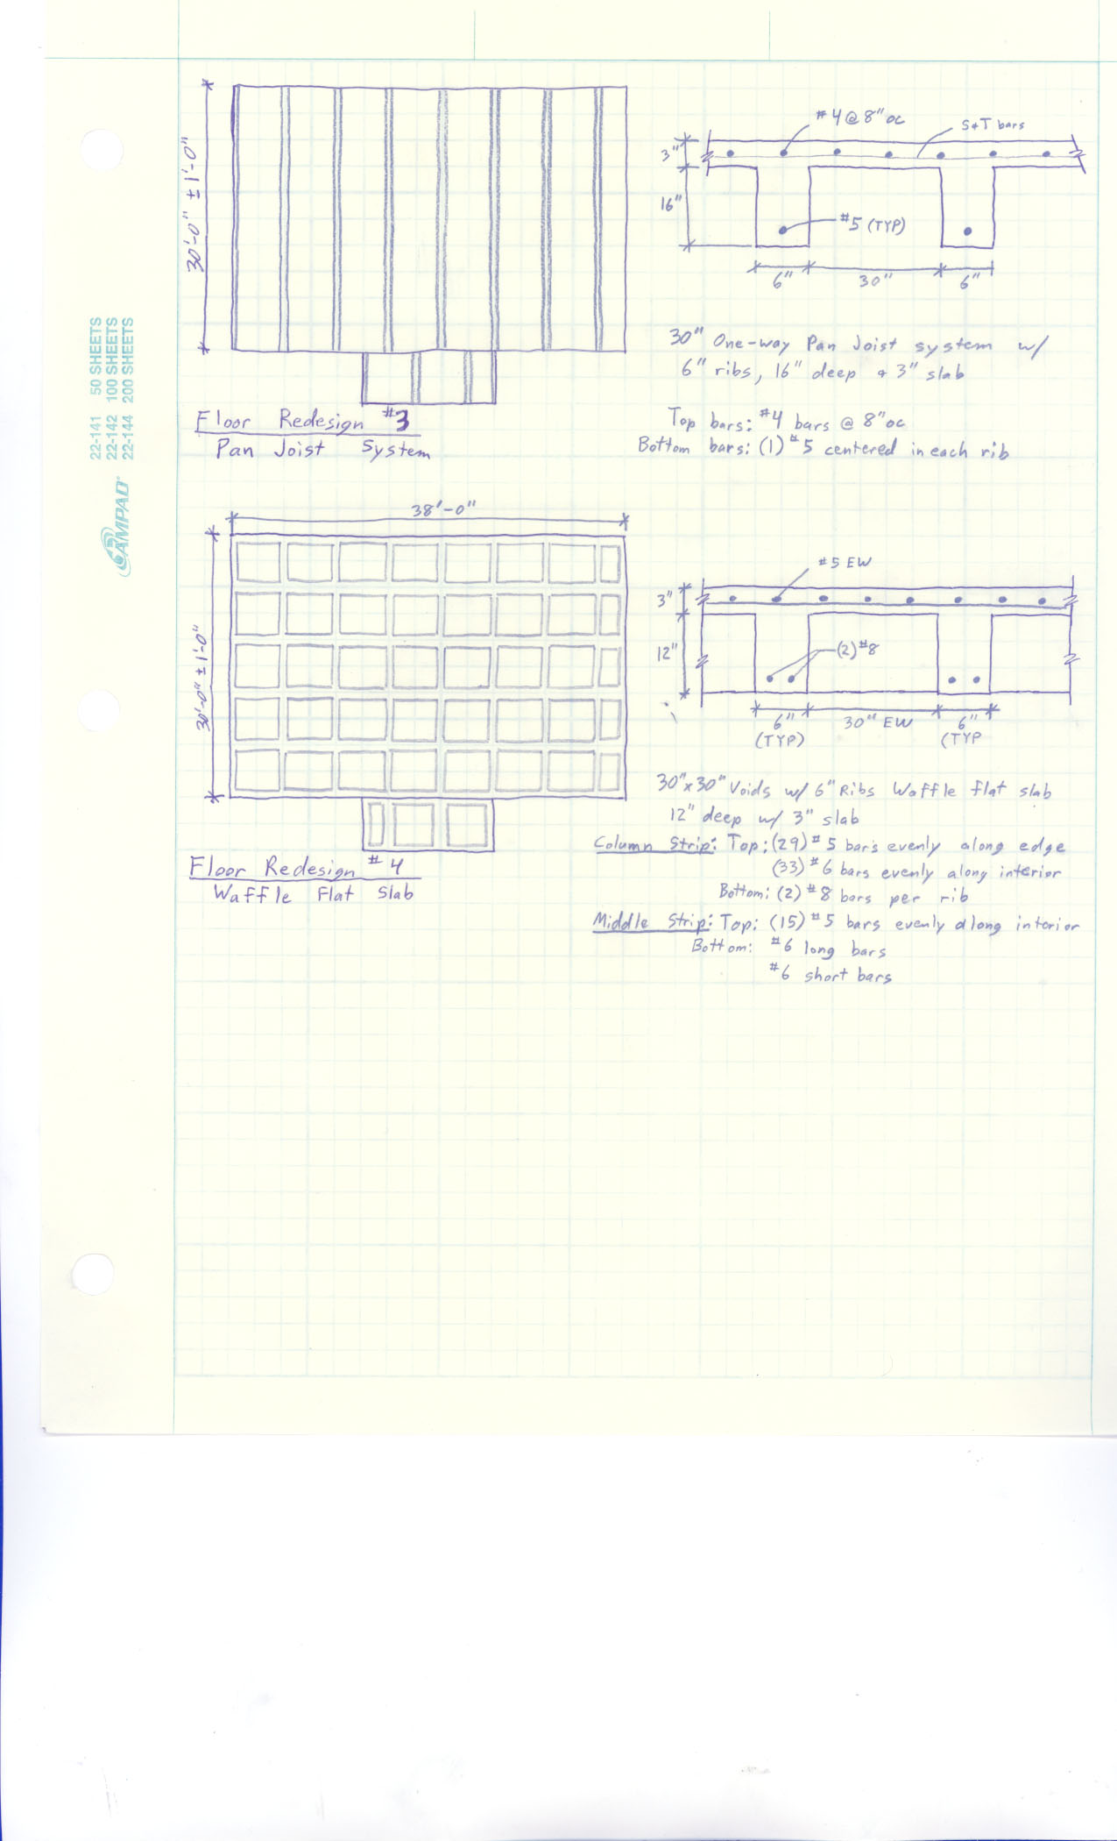

Due to its thickness, the pan joist system provides a 3 hour fire rating and effectively damps out noise and vibrations in the system. Furthermore, with the mechanical equipment having to pass below the joists, there is little chance for water penetration into the concrete, making this a very durable floor.

Strength wise this is a good choice for a floor, yet the excessive weight in addition to its large depth make this a less viable solution for this building. This floor system will not need to be analyzed more extensively due to the nature of the building requirements of Parkview at Bloomfield Station.
Alternate Floor Framing Option #4

The fourth redesign is a 15” deep 2-way concrete waffle flat slab. This floor, like the previous floor option, is composed solely of concrete and will need to be supported by a concrete frame system. Since this is a 2-way system, the column sizes will be slightly smaller due to load sharing, creating slightly less intrusion on the existing architectural layout. In addition, beams along the column line aid in the gravity and lateral load carrying capacity of the frame.

This system will support the mechanical ductwork below the joists, attached just like the ductwork in the concrete joist system. Even with this additional 3”to 6”, it will be comparable in depth to the Hambro floor. Furthermore, since the mechanical equipment is located below the joists, water damage to the concrete will be prevented and will allow this floor to outlive the building life.

Since this system is composed of concrete joists in both directions it allows for excellent strength carrying characteristics. However, it is the heaviest of the five designs, having a total weight of 90 psf and requiring a much larger foundation. This floor system is not only the heaviest, but also has the slowest erection time due to the alignment of formwork in both directions. This time consuming procedure has led this floor system to have the highest price tag of all five systems in consideration. However, the heavy floor system does have its advantages as a damping system by not only reducing sound but also greatly reducing floor vibrations. Fire rating is also not a problem due to its mass, easily obtaining a 3 hour fire rating.

Based on serviceability requirements this is a good design, however, it does not appear to be a good solution on many other levels. Its primary downfall is its excessive weight and moderate depth. These 2 factors combined with the time consuming aspect of layout led to the conclusion that this system does not need any further investigation.

Alternate Floor Framing Option #5

The fifth floor redesign is an 8” deep 1-way pre-stressed concrete slab. The mechanical ductwork would need to be attached to the bottom of the panels adding 3”-6” to the system, making the overall depth 14” at most, a difference of 5” minimum from the Hambro system.

This system, while thinner overall, has a system weight of 100 psf, two and a half times the weight of the Hambro system. This added weight, along with the required end supports means that the support system needs to be a concrete frame. This support system affects the architectural layout of the apartment by requiring wall bump-outs at the column locations. This load difference will also increase the required footing sizes and change the lateral resisting elements from shear walls to braced frames with lightgage infill. It will also reduce the ability to put slab penetrations at certain locations due to the pre-stressed cables.
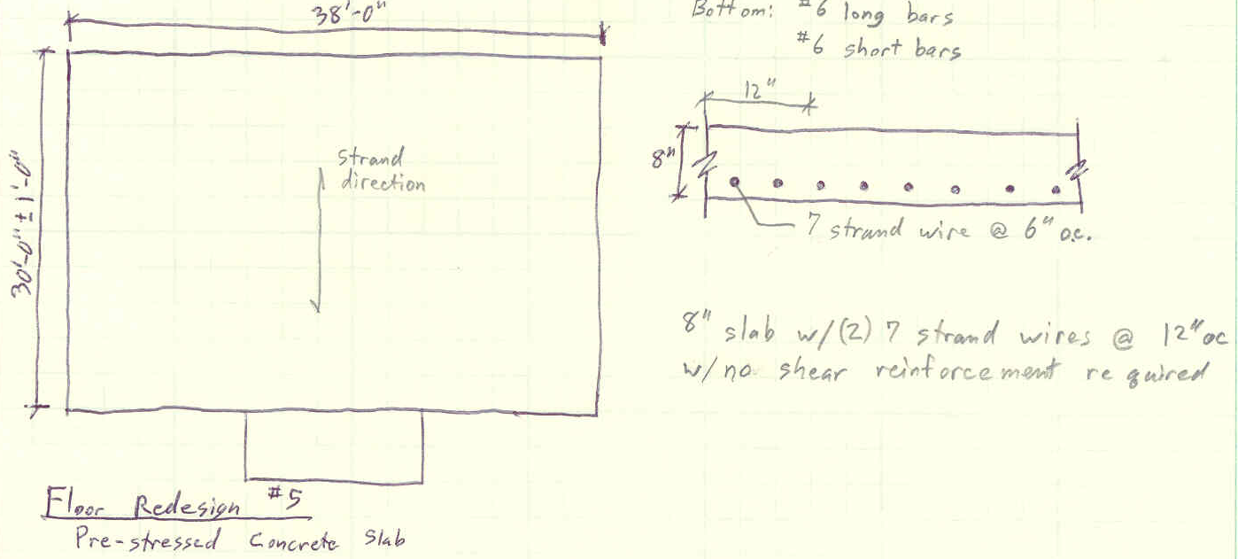

The overall cost of the pre-stressed system is much higher than the Hambro system due to its complexity and specialization. It would require specialized machines to be onsite for the tensioning and engineering oversight. However, the system does have a fire rating of 3 hours and also has comparable IIC and STC to that in the Hambro system due to its rigidity. The reduction of ceiling-to-floor height will allows the building to have either higher finished ceilings or reduced building height by nearly 3 feet. This system, like the others will last for the life of the building. While this floor system has excellent depth characteristics, its drawbacks with respect to weight and specialization make it a poor alternative to the current floor system. It will not need to be investigated as a potential floor system any further.
Alternate Floor Framing Comparison

While the bar joist and hollow core plank systems both rank high, the best floor redesign to parallel the Hambro system is the hollow core plank floor system. The bar joist system is close in design to the Hambro system yet lacks any extended benefits that would make it a better choice. Since it shows no extended benefits it will not need to be considered further, despite its high viability.

The hollow core plank system features a shorter depth (10” + 3” to 6”), and a fast erection time. This system is also a less complex option overall and reasonably close in cost to the Hambro system. However, a change in supporting structure from lightgage walls to a steel or concrete frame will be required, causing some changes to the existing architecture. It also has a system weight nearly double the current floor weight, and will require larger foundations. Finally, additional fireproofing will need to be considered since the hollow core plank system only has a 2 hour fire rating. Yet despite these slight setbacks to the overall floor system, it appears that this system is a viable solution for Parkview at Bloomfield Station’s flooring needs.

www.hambrosystems.com IIC is a rating designed to measure the impact sound isolation provided by floor/ceiling construction. The IIC of any assembly is strongly affected by and dependent upon the type of floor finish for its resistance to impact noise transmission. STC is a rating that assigns a numerical value to the sound insulation provided by a partition separating rooms or areas. The rating is designed to match subjective impressions of the sound insulation provided against the sounds of speech, music, television, office machines and similar sources of airborne noise that are characteristic of offices and dwellings.
The New Columbia Joist Company. http://www.njb-united.com/ncj.htm
Nucor Corporation: Vulcraft Division. http://www.vulcraft.com/

