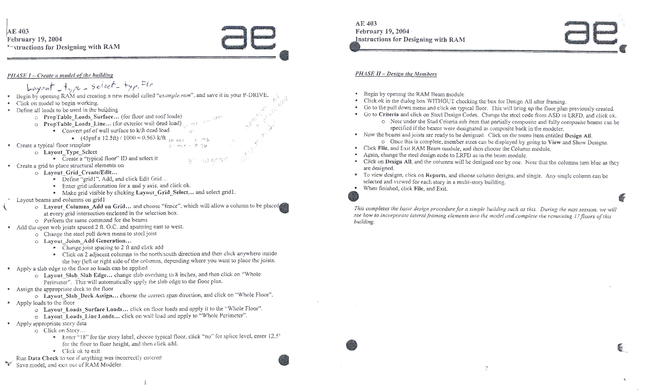
Layout_ type_ select_ typ. floor
To view model upon reopening: Layout_ type_ select_ typ. floor


- Exit model to beam module
- Go to process_ Design all
  - Go to view_ show designs
- Exit to column module
- Go to process_ Design all
  - Designed columns will change color to blue
  - To view designs, click on Reports, and choose column designs, and single. Any single column can be selected and viewed for each story.
- Exit model to frame module

- To view model upon reopening: Layout_ type_ select_ typ. floor
  - Make sure you assign a size to each brace in the frame while assigning the layout

3

- If a member fails within the frame modeler
- Go to process_ member view/update
- Select each failing member
  - Select a larger beam size and hit update database
  - Verify green light for interaction diagram and hit close
  - Be sure to rotate view to make sure all members have been updated

PHASE VI – Design the Footing system
- If a all members are passing exit the frame modeler and enter the footing modeler
  - Note: this modeler will only work once the frame analysis is done.
  - Go to process_ design all
    - Design the spread and continuous footings

4
- Apply footings to the building
  - If the bottom floor is different from the upper floors create a floor called “Bottom Floor”
    - Layout_ type_ select
      - Type in “Bottom floor” and select it
    - Layout_ type_ copy
      - Copy the “All” data from the middle floors
    - Layout_ foundations
      - Add spread and continuous footings as needed
        - Add spread footings first and fence entire building
        - Locate areas where strip footings are needed and delete any spread footings that are in their path. Then add the strip footings.
    - Note: Make sure you have placed the “Bottom Floor” on the story data

4

