Acrylic Clock
Production Quantity = 50

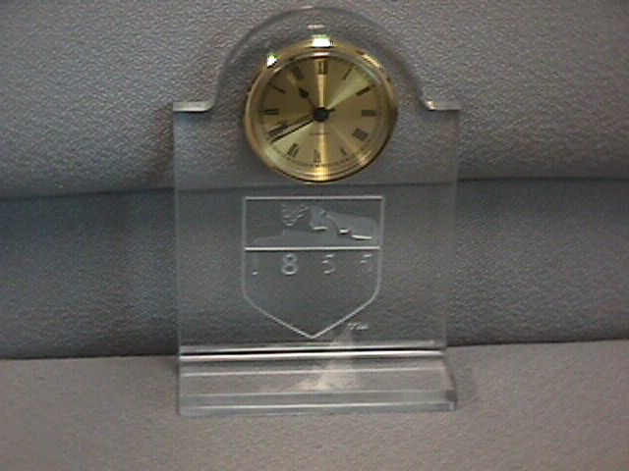

This acrylic clock has two manufactured pieces. The background, which has a logo and an indentation for the clock insert, and the base, which simply has a groove in the top for the background to connect to it. The processes that are currently used to produce this clock is as follows.

Process Summary for Base

Set Up Number

Operation Description

Machine Tool Description

10

Cut-off 0.50 in. x 2.25 in. cross-sections of cast sheet acrylic stock to a length of 5.25 ± .015 in.

Cut-off Saw

20

Fabricate background housing on the planar surface.

3 axis vertical machining center

30

Polish all surfaces of the base

Sanding and Buffing

Tools Currently Used for Setup 20 of Base
(Making the slot in the top of the base)

•MACHINE TOOLS: Vertical Machining Center, VF-OE

•FIXTURE: Kurt Vise with 1 ¼” parallels

•CUTTING TOOLS: 1/2 inch Double Flute End Mill

•MISCELLANEOUS TOOLS: Edge Finder, Dial Indicator

Operation Number

Operation Description

Tool Number

Tool Description

Important Process Parameters

1

Slot mill in one pass

1

1/2-inch end mill

d = .125 in.
w = 5.25 in.
V = 3000 rpm
F = 15 ipm

CAD Drawing of Background
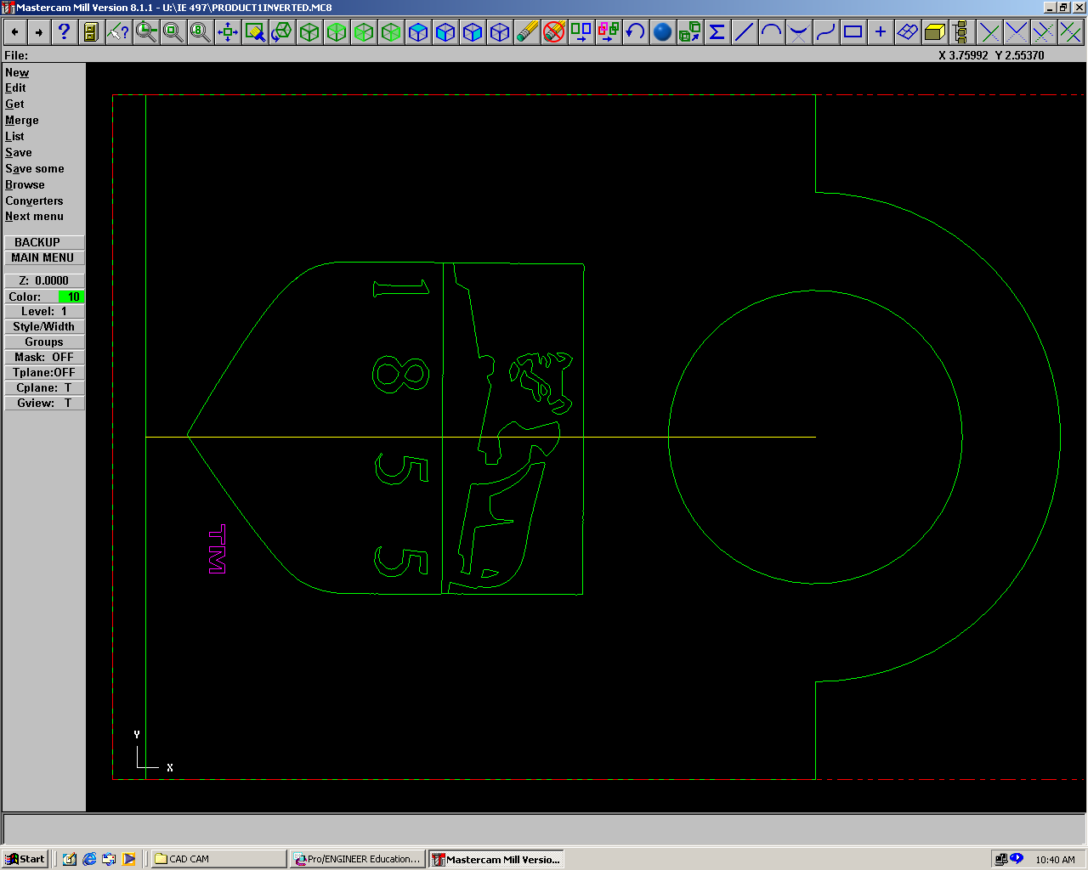

Process Summary for Background
Set Up Number
Operation Description
Machine Tool Description
10

Cut-off a 0.50 in. x 5.25 in. cross-section of cast sheet acrylic stock to a length of 8 ± .015 in.

Cut-off Saw

20

Machine PSU logo, fabricate clock housing, and circular contours on the planar surface.
3 axis vertical machining center

30

Polish all surfaces of the background

Sanding and Buffing

Tools Currently Used for Setup 20 of Background
(Making the PSU logo, clock housing, and circular contours)

•MACHINE TOOLS: Vertical Machining Center, VF-OE

•FIXTURE: Kurt Vise with 1 ¼” parallels with stop

•CUTTING TOOLS: 1/32” Double Flute End Mills

•MISCELLANEOUS TOOLS: Edge Finder, Dial Indicator

d = 0.60in.
V = 2400 rpm
F = 10 ipm

1/2-inch end mill
2
End mill clock housing on the planar surface
3
d = 0.600 in.
V = 2400 rpm
F = 10 ipm
1/2-inch end mill
2
End mill circular contours on the planar surface
2
d = 0.02 in.
V = 15000 rpm
F = 17.0 ipm
1/32-inch end mill
1
End Mill PSU logo on the planar surface
1
Important Process Parameters
Tool Description
Tool Number
Operation Description
Operation Number

Final Assembly of the Clock

•Join the base and the background by press fitting and acrylic glue
•Insert battery into clock insert
•Place clock insert into clock housing

