Product Dissection of an Electric Milk Frother

You will have 30 minutes to complete this part.

Product dissection is often done in industry and academia to uncover opportunities for re-design. Designers take apart and analyze all components of a product to understand its structure and properties, and thus, find ways to improve the product. Therefore, the goal of dissection is to improve the functionality, maintainability, and reliability of a product through the examination, study, capture, and modification of existing products.

During this activity, you will perform a virtual product dissection on the provided product by taking it apart and analyzing the function of each component. Your goal is to understand strengths and weaknesses of the product in order to develop new innovative concepts that satisfy the design goal.

Once again, the goal is to develop concepts for a new, innovative product that can froth milk in a short amount of time. This product should be able to be used by the consumer with minimal instruction.

Task 1:
Take apart the product using the computer interface and the on-screen instructions. Your task is to disassemble the product, identify each part, and record the following in Table 1:

QTY: Quantity of each part within the product. Eg. If there were 4 batteries you would write 4 in this box.
Material: The material the part is made from (if you do not know for sure, write your best estimate)

Table 1: Bill of Materials of the Dissected Product
Part# | Part Name | QTY | Material
1 | Outside Case (right)
2 | Outside Case (left)
3 | Motor
4 | Switch
5 | AA Batteries
6 | Battery Case (bottom)
7 | Battery contact
8 | Motor Connector
9 | Wand
12 | Top stopper
13 | Spring

Task 2:
The goal of this task is to visualize how the product is assembled and identify what function each part plays in the functionality of the product. For this task, you should sketch out the individual parts you identified in Task 1 on the provided sheet of paper. You may use more than 1 sheet of paper if you run out of space. Try to sketch the parts such that they are close to parts that they would be adjacent to without disassembly. Your layout should include the following information:

- Name of each part
- The function that you perceive that part to serve
- Each part’s connectivity to the next (use arrows)

For an example of what your completed layout should look like, refer to Figure 1. Keep in mind the design task while performing the product dissection:

The main goal of your task is to develop concepts for a new, innovative product that can froth milk in a short amount of time. This product should be able to be used by the consumer with minimal instruction.

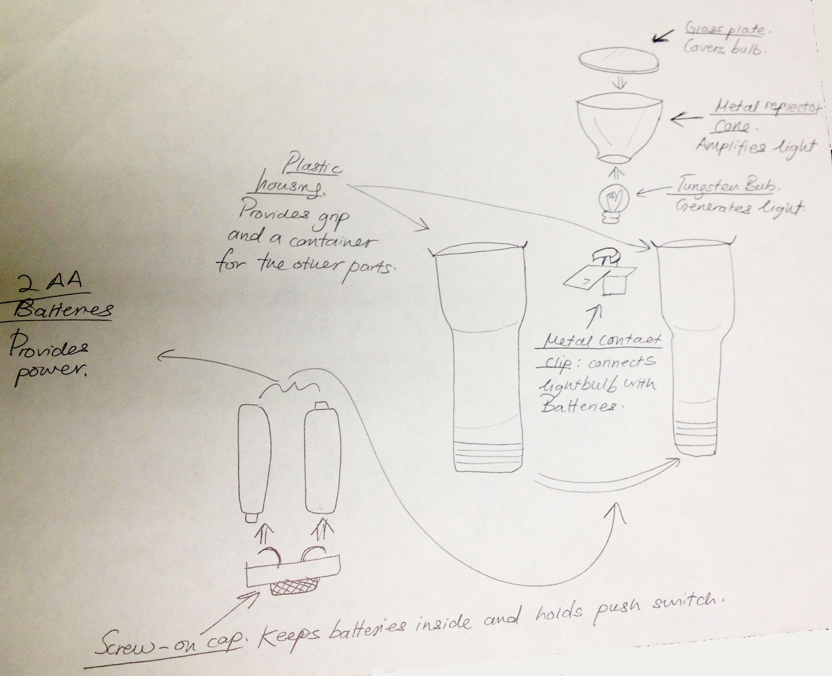
Figure 1: Example layout sketch of dissected parts with their purpose and connectivity.

